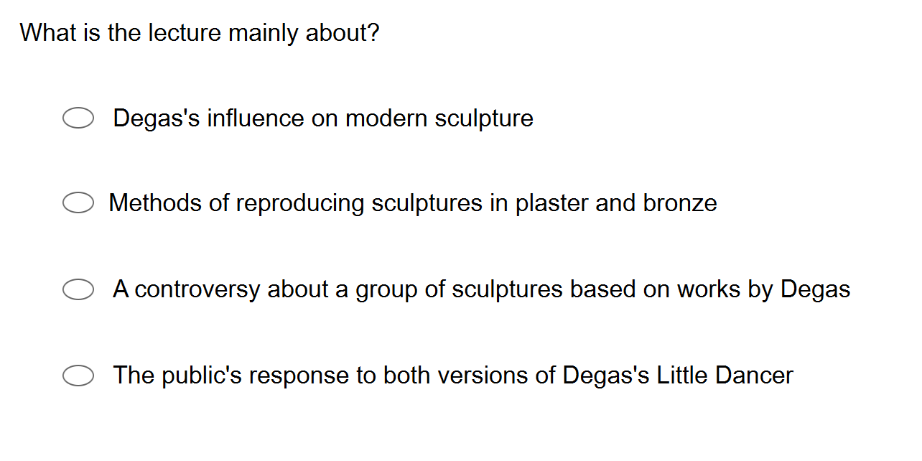

2.

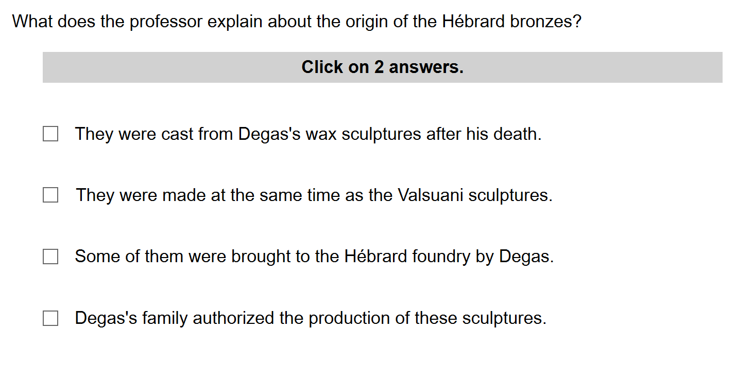

3.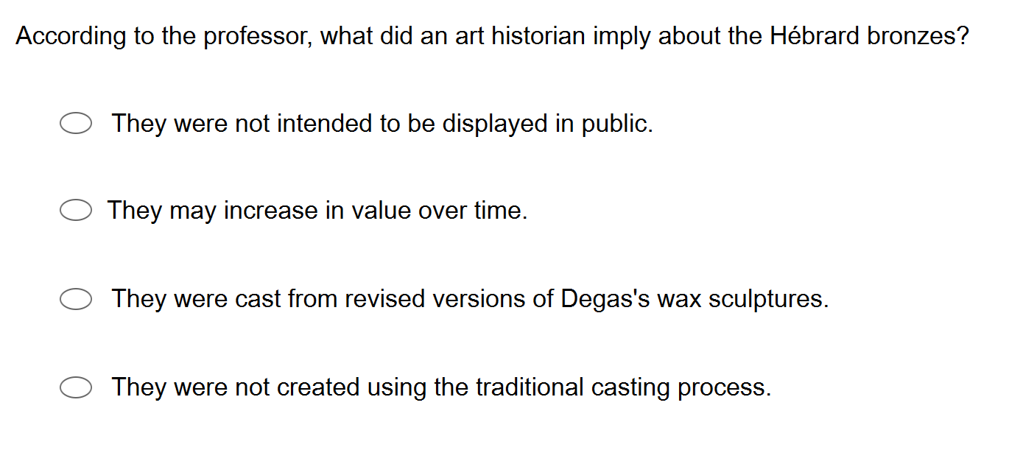

45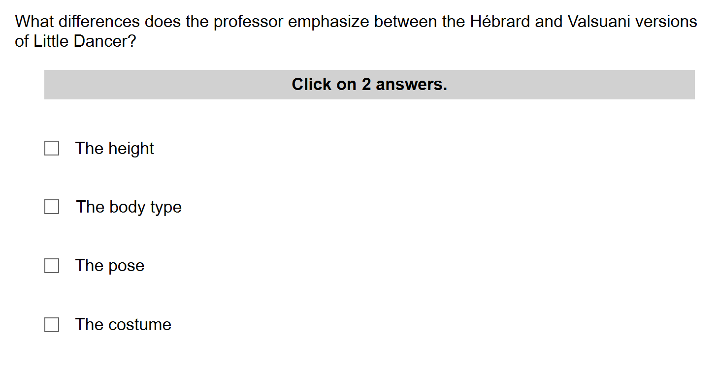

5.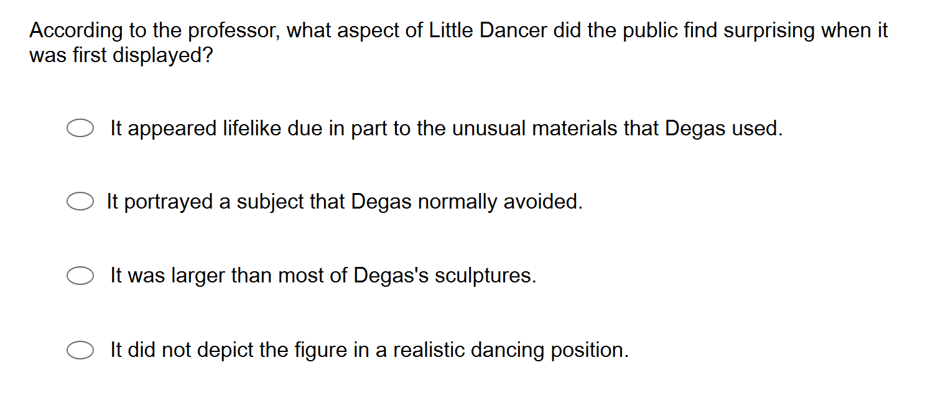

6.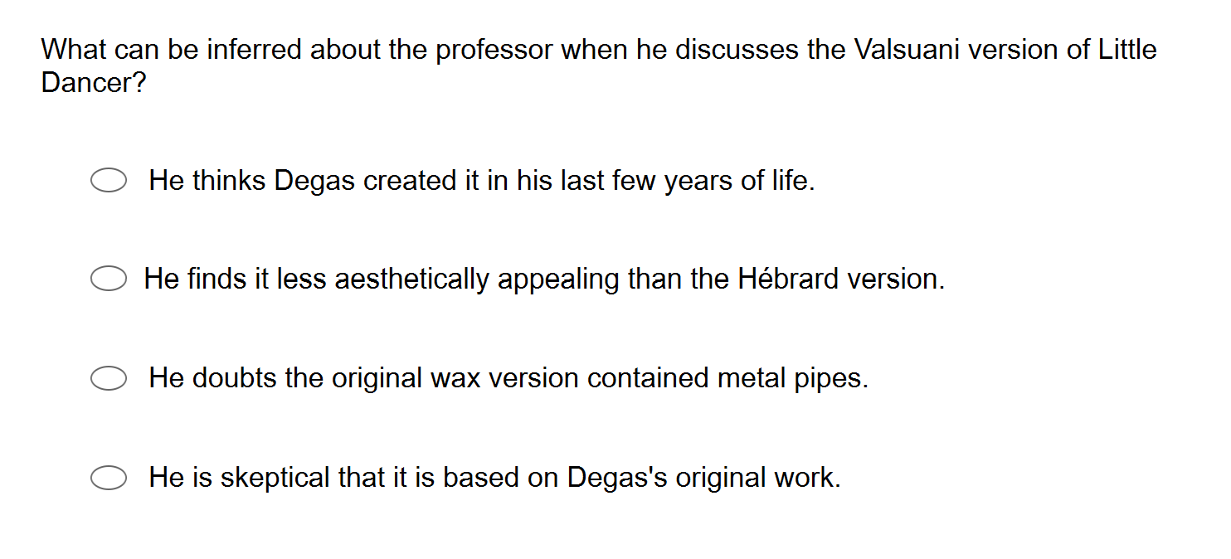

Group Work

Answer these questions:

1. How to describe Degas? (Not only … but also…)
2. After his death, what happened?
3. How to cast a sculpture? Steps
4. What shift happened after Hébrard foundry closed ?
5. Then what happened that took the art world by surprise?
6. What was the debate?
7. Describe “little dancer at age 14”.
8. What are the differences of the two versions.

In the Hébrard version:

In the valsuani version:

1. How did people investigate the wax sculpture? (using what?)

10. What is the professor’s attitude about whether Degas had revised his work? Why?

Listen to part of a lecture, in an, art history class. The professor has been discussing the French artist, Edgar Degas.

<https://www3.metmuseum.org/about-the-met/conservation-and-scientific-research/conservation-stories/2020/degas-dancer>

1. **How to describe Degas? (Not only … but also…)**

So far, we focused on the Degas 's paintings. As you've seen, he's considered one of the great painters of 19th century France, and was best known for his depictions of dancers. But Degas wasn't only a painter. He was also a sculptor. Degas liked to use soft materials like wax and clay to create his sculptures.

1. **After his death, what happened?**

After his death. His family selected 74 wax sculptures from his home and studio, and commissioned a foundry, which is a business where metal working is done to make bronze copies of them. These reproductions are known as the Hébrard Bronze. They're named after the foundry 铸造厂 that produced them. The technique they used is pretty common. It's called casting 浇筑.

1. **How to cast a sculpture? Steps**

First, you apply wet plaster 石膏to the sculpture. Once it drives. You take the hardened plaster off and you have a mold in the shape of the original. At that point, you can use the mold to cast copies in bronze or some other material. So the Hébrard foundry made over 500 reproductions of these 74 sculptures. And these reproductions were acquired by museums and art collectors around the world.

1:27’

1. **What shift happened after Hébrard foundry closed ?**

However, the Hébrard foundry closed in 1937. And with the authorization of the family, the manufacturer of Degas bronzes then shifted to a different foundry, called the valsuani foundry in Paris.

1. **Then what happened that took the art world by surprise?**

By 1981, valsuani was under new ownership. And then something happened **that took the art world by surprise.** The new owner revealed an entirely different set of 74 plaster sculptures, claimed to be based on wax sculptures by Degas. These plasters and the bronze is made from them, are called the valsuani sculptures, named once again, after the foundry that produced them.

In many ways, they looked very similar to the Hébrard copies, but the two sets were not identical. There were actually some noticeable differences between them. So of course, art experts wondered how that could be.

1. **What was the debate?**

**Now we know that** the Hébrard bronzes were cast from wax sculptures found in Degas’s home and studio. We had no reason to think that the valsuani bronzes were authentic. **But then** one art historian **made a remarkable claim**. He said, that Degas used to go back to his wax sculptures from time to time and change them, reshape them. And he claimed that the valsuani set was made from the older versions of those wax sculptures.

Well, you can imagine what a debate that claims created.

1. **Describe “little dancer at age 14”.**

Let's consider one of the most famous of the 74 sculptures little dancer at age. 14. Little dancer is the figure of a girl, not quite life size, but fairly tall. In a standing pose with her hands clasped behind her.

1. **What are the differences of the two versions.**

**In the Hébrard version:**

**In the Valsuani version:**

In the Hébrard version, the dancer stands with her weight on her left leg, with her right leg out in front of her slightly bent the knee.

In the valsuani version, she stands with her weight evenly distributed on both legs and with both knees bent a much more solid stance.

And her body type is different, too. In the Hébrard version, her legs are slim. In the valsuani version. More muscular.

Little dancer is the only one of Degas’s wax sculptures shown in public during his lifetime. It was displayed in Paris in 1881. **And this art historian insisted that** the sculpture exhibited there was the one the valsuani version is made from.

Now, unfortunately, we have no photographs of the sculpture from the exhibition. So it's hard to know what the viewers saw. A girl with her weight on one leg, or a girl with her weight on both. We do have written accounts, but they're inconsistent and unreliable. That's probably because people were shocked by how realistic the sculpture appeared. They got even put a little cotton skirt on the wax figure and a wig 假发made out of real hair.

1. **How did people investigate the wax sculpture? (using what?)**
2. **What is the professor’s attitude about whether Degas had revised his work?**

But there are other ways to investigate the wax sculpture of little dancer with her weight on her back leg is now in a museum in Washington, DC and researchers have examined its structure using x rays and scanning technology. They found that the dancers legs contain metal pipes that provide structural support. But I mean, there's no sign that the pipes were ever moved. And for Degas to change the position of the legs and hips so drastically, they would have had to have been moved. Revisions would have been extremely difficult if not downright impossible to make.